# **C Programming Questions and Answers**

**C Programming Questions and Answers** has been designed with a special intention of helping students and professionals preparing for various **Certification Exams** and **Job Interviews**. This section provides a useful collection of sample Interview Questions and Multiple Choice Questions (MCQs) and their answers with appropriate explanations.

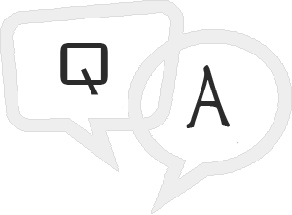

|  |  |
| --- | --- |
| **Sr.No** | **Question/Answers Type** |
| 1 | [C Programming Interview Questions](https://www.tutorialspoint.com/cprogramming/cprogramming_interview_questions.htm)  This section provides a huge collection of C Programming Interview Questions with their answers hidden in a box to challenge you to have a go at them before discovering the correct answer. |
| 2 | [C Programming Online Quiz](https://www.tutorialspoint.com/cprogramming/cprogramming_online_quiz.htm)  This section provides a great collection of C Programming Multiple Choice Questions (MCQs) on a single page along with their correct answers and explanation. If you select the right option, it turns green; else red. |
| 3 | [C Programming Online Test](https://www.tutorialspoint.com/cprogramming/cprogramming_online_test.htm)  If you are preparing to appear for a Java and C Programming Framework related certification exam, then this section is a must for you. This section simulates a real online test along with a given timer which challenges you to complete the test within a given time-frame. Finally you can check your overall test score and how you fared among millions of other candidates who attended this online test. |
| 4 | [C Programming Mock Test](https://www.tutorialspoint.com/cprogramming/cprogramming_mock_test.htm)  This section provides various mock tests that you can download at your local machine and solve offline. Every mock test is supplied with a mock test key to let you verify the final score and grade yourself. |